Design and Development of an AI-Enabled Web-Based Eyewear Inventory and E-Commerce Management System (iWear) with an AI Business Insights Assistant
MSc Masters Project Specification
Supervisor: Tariq Alsboui Date: 17-Feb-2026

1. Abstract
The rapid advancement of digital technologies and e-commerce platforms has significantly transformed modern retail operations. Small and medium-sized enterprises (SMEs) increasingly rely on web-based systems to manage inventory, sales, and customer relationships. Despite this shift, many optical and eyewear retailers still depend on manual processes or basic spreadsheet-based solutions, which result in inefficiencies, data inaccuracies, poor stock control, and limited visibility of business performance.
This project proposes the design and development of an AI-enabled web-based Eyewear Inventory and E-Commerce Management System, named iWear. The system integrates inventory management, product catalog management, online ordering using a cash-on-delivery model, and eyewear-specific customization, including frame selection, lens options, and prescription data input. In addition, the system includes an AI Business Insights Assistant that allows store owners to retrieve business reports such as daily sales, profit, and best-selling products using natural-language queries.
The project will adopt an iterative and incremental development methodology encompassing requirements analysis, system design, implementation, testing, and evaluation. Modern web technologies will be employed to ensure scalability, usability, and security. The expected outcome is a functional prototype that demonstrates the effective application of computing and artificial intelligence techniques to address real-world challenges faced by eyewear retailers.
In addition to inventory management, the iWear system incorporates a customer-facing e-commerce module that supports eyewear-specific customisation, including frame selection, lens options, and prescription data input. Furthermore, the system integrates an AI Business Insights Assistant designed to provide store owners with accessible business intelligence through natural-language queries. Together, these components form a unified platform that supports operational efficiency, customer experience, and data-driven decision-making within the eyewear retail domain.

3. Justification and Overall Aim

3.1 Justification
Small and medium-sized retail businesses generate significant amounts of transactional data through daily sales, inventory updates, and customer interactions. Despite the availability of this data, many eyewear retailers struggle to extract meaningful insights that could support informed decision-making. Business owners often rely on manual reporting methods or static spreadsheets to monitor performance, which are time-consuming, error-prone, and unsuitable for real-time analysis.
A key limitation faced by SMEs is the lack of technical expertise required to interact with database systems or advanced business intelligence tools. Traditional analytics platforms often rely on complex dashboards, structured query languages, or specialised training, making them inaccessible to many small business owners. As a result, important business decisions related to pricing, stock replenishment, and sales performance are frequently based on intuition rather than data-driven evidence.
Research in the field of business intelligence emphasises the importance of accessible and user-friendly analytical tools for SMEs. Conversational analytics systems have emerged as a promising solution by allowing users to interact with data through natural-language queries. These systems reduce the learning curve and enable non-technical users to retrieve insights without requiring knowledge of underlying data structures. However, many existing AI-based analytics solutions are designed for large enterprises and involve complex machine-learning models, extensive configuration, and high operational costs. Such solutions are often unsuitable for small retail businesses due to their complexity, lack of transparency, and resource requirements.
Furthermore, complex AI models can introduce challenges related to interpretability and reliability. For decision-support applications in SME environments, transparency and predictability are often more valuable than advanced predictive capabilities. Business owners need to understand how insights are generated in order to trust and act upon them. Rule-based conversational systems offer a practical alternative by providing deterministic and interpretable responses to predefined queries.
The justification for this individual project component lies in the need for a lightweight, transparent AI-based reporting solution tailored specifically to SME eyewear retailers. By implementing a rule-based AI Business Insights Assistant, the project aims to provide accessible, reliable, and cost-effective analytics functionality. This approach enables business owners to retrieve essential performance metrics without relying on complex tools or advanced technical skills, directly addressing a gap identified in existing business intelligence solutions.

3.2 Overall Aim
The overall aim of this individual project component is to design and implement a transparent, rule-based AI Business Insights Assistant that enables eyewear retailers to retrieve key business reports, such as sales summaries and product performance metrics, through natural-language queries, thereby supporting data-driven decision-making in SME environments.

4. Objectives
The objectives of this individual project component are structured to be specific, measurable, achievable, relevant, and time-bound (SMART). Together, they support the systematic design, implementation, and evaluation of the AI Business Insights Assistant within the iWear system.
The first objective is to analyse business reporting requirements for eyewear retailers. This involves identifying the key performance indicators that are most relevant to small optical businesses, such as daily sales totals, profit summaries, and best-selling products. Understanding these requirements ensures that the assistant provides information that is both practical and valuable for decision-making.
The second objective is to design a conversational interface that supports natural-language business queries. This objective focuses on enabling users to interact with the system using simple and intuitive language, reducing the need for technical knowledge or structured query syntax.
Another objective is to implement intent detection mechanisms for common reporting requests. This involves analysing user input to identify the underlying intent, such as requesting sales data or inventory summaries. Successful intent detection is essential for generating accurate and relevant responses.
The project also aims to map detected intents to predefined database queries. This objective ensures that user requests are translated into reliable and efficient data retrieval operations, allowing the assistant to access relevant information from the inventory and sales database.
In addition, the project seeks to generate clear and accurate textual and tabular responses. These responses are designed to present business information in a format that is easy to understand for non-technical users.
Finally, the project aims to integrate the AI assistant with the existing inventory and sales database and to evaluate the system for accuracy, usability, and reliability. Evaluation is conducted through testing scenarios that assess response correctness and user satisfaction.

5. Literature Review
Artificial intelligence has increasingly been applied to business intelligence (BI) systems with the aim of improving accessibility, efficiency, and decision-making quality. Traditional BI tools typically rely on dashboards, reports, and structured query languages, which often require technical expertise to use effectively. For small and medium-sized enterprises (SMEs), this complexity creates a barrier to adoption and limits the practical use of available business data. As a result, there has been growing academic and industrial interest in conversational analytics systems that enable users to interact with data using natural language.
Chen, Chiang and Storey (2012) highlight the expanding role of analytics in organisational performance and strategic decision-making. Their work emphasises that data-driven insights can provide competitive advantages when they are timely, accurate, and accessible to decision-makers. However, they also note that the effectiveness of analytics systems depends heavily on their usability and alignment with organisational capabilities. For SMEs, overly complex analytical tools often fail to deliver value due to limited technical resources and expertise.
Conversational analytics systems address this challenge by allowing users to query data using natural-language input. These systems reduce reliance on technical skills by translating user queries into underlying data retrieval operations. Research suggests that conversational interfaces can significantly lower the learning curve associated with BI tools, making analytics more accessible to non-technical users. This is particularly relevant in retail environments, where business owners may need quick access to insights without extensive training.
Chatbots and conversational agents have been widely studied in both academic and industrial contexts. Adamopoulou and Moussiades (2020) provide a comprehensive overview of chatbot technologies, categorising them into rule-based, retrieval-based, and machine-learning-based systems. Rule-based chatbots operate using predefined patterns and responses, offering predictable and interpretable behaviour. In contrast, machine-learning-based systems rely on training data and statistical models to generate responses, enabling greater flexibility but introducing challenges related to transparency and control.
In decision-support applications, interpretability and reliability are critical considerations. Recent research emphasises that users are more likely to trust and adopt AI systems when they can understand how outputs are generated. For SMEs, transparent systems that provide consistent and explainable results are often more valuable than complex models that produce opaque outputs. Rule-based conversational systems are therefore frequently preferred in academic and SME environments, where system behaviour must be predictable and easy to validate.
Several studies highlight the limitations of applying advanced machine-learning models in small business contexts. These models often require large datasets, continuous training, and specialised expertise to maintain. Additionally, errors or unexpected outputs can undermine user trust, particularly when systems are used to support business decisions. In contrast, rule-based systems offer deterministic behaviour, making them easier to test, debug, and evaluate within constrained project scopes.
Business intelligence literature also stresses the importance of tailoring analytics solutions to specific domains. Generic BI tools may fail to capture domain-specific reporting needs or operational constraints. In the context of eyewear retail, business owners require access to metrics such as daily sales performance, profit summaries, and product-level insights. Integrating conversational analytics with inventory and sales data enables more contextual and actionable reporting.
Despite the growing body of research on conversational analytics and chatbots, relatively limited attention has been given to their application in SME retail environments, particularly within specialised domains such as eyewear retail. Many existing solutions are designed for large enterprises and prioritise scalability and advanced analytics over simplicity and usability. This creates a gap in the literature regarding lightweight, transparent analytics systems that align with SME capabilities.
This project builds upon existing research in conversational analytics and business intelligence by applying a rule-based AI approach to eyewear retail reporting. By focusing on interpretability, predefined intent handling, and seamless integration with operational databases, the proposed AI Business Insights Assistant addresses limitations identified in previous studies. The literature supports the view that domain-specific, transparent AI systems can enhance data accessibility and decision-making for SMEs, reinforcing the relevance and contribution of this project.

6. Methodology
An iterative and incremental development methodology is adopted for the development of the AI Business Insights Assistant. This approach is well suited to conversational and decision-support systems, as it allows the assistant to be designed, implemented, tested, and refined in multiple stages. By developing the system incrementally, issues related to intent recognition, response accuracy, and usability can be identified early and addressed before extending functionality.
The iterative approach also supports continuous improvement based on testing outcomes and simulated user interactions. This is particularly important for SME-focused analytics systems, where usability, reliability, and interpretability are more critical than advanced predictive capabilities. The methodology ensures that the assistant evolves in a controlled and transparent manner, aligning with both academic scope and practical constraints.

6.1 AI Assistant Design
The AI Business Insights Assistant is implemented as a rule-based conversational system. This design choice is motivated by the need for transparency, predictability, and ease of validation. In contrast to machine-learning-based chatbots, rule-based systems operate using predefined patterns and responses, making system behaviour deterministic and easier to evaluate.
User queries are processed using basic natural-language processing (NLP) techniques such as keyword matching, pattern recognition, and simple text normalisation. These techniques allow the system to identify relevant terms and phrases associated with common business reporting requests. For example, queries containing terms such as “daily sales”, “profit”, or “best-selling products” can be matched to predefined intents.
The rule-based design ensures that the assistant responds consistently to similar inputs and avoids unpredictable behaviour. This is particularly suitable for academic projects and SME environments, where system reliability and interpretability are prioritised over flexibility.

6.2 Intent Mapping and Query Execution
Once user intent is detected, the assistant maps the identified intent to a predefined structured query language (SQL) query. Each supported intent corresponds to a specific database query designed to retrieve relevant business information. These queries access the inventory and sales database to obtain metrics such as total sales for a given period, profit summaries, or product performance statistics.
This mapping approach ensures that user queries are translated into reliable and efficient database operations. By restricting query execution to predefined templates, the system avoids risks associated with arbitrary or malformed queries. This design choice also improves security and system stability.
SQL queries are designed to be optimised for performance and clarity. Aggregation functions and filtering conditions are used to compute required metrics accurately. The separation between intent detection and query execution simplifies system maintenance and allows additional reporting intents to be added in future iterations.

6.3 Response Generation
Query results retrieved from the database are formatted into clear and concise responses suitable for non-technical users. The assistant generates both textual summaries and simple tabular outputs, depending on the nature of the query. For example, a sales summary query may produce a short explanatory sentence accompanied by a table displaying key figures.
Response generation prioritises clarity and interpretability. Numerical values are presented in an understandable format, and brief explanations are provided to help users interpret the results. This approach reduces cognitive effort and ensures that business owners can quickly act on the information provided.
The assistant avoids overly technical terminology and focuses on delivering actionable insights. By maintaining consistency in response structure, the system improves usability and user trust.

6.4 Testing Strategy
A structured testing strategy is employed to evaluate the functionality, reliability, and usability of the AI Business Insights Assistant. Testing focuses on several key aspects, including intent detection accuracy, response correctness, and system stability.
Functional testing is conducted to verify that each supported intent produces the correct database query and corresponding output. Test cases include common reporting requests as well as edge cases, such as incomplete or ambiguous user queries. These tests help assess the robustness of the intent detection logic.
Usability testing evaluates whether non-technical users can effectively interact with the assistant and understand the generated responses. Test scenarios simulate realistic usage patterns, ensuring that the assistant provides meaningful feedback even when queries are phrased differently.
Testing results are documented and analysed to identify limitations and guide further refinement during iterative development.

6.5 Ethical and Practical Considerations
The AI Business Insights Assistant processes aggregated business data rather than personal customer information. As a result, ethical risks related to privacy and data protection are limited. Nevertheless, secure access controls are implemented to restrict assistant usage to authorised users only.
From a practical perspective, the project scope and academic timeline influence design decisions. Advanced machine-learning models and predictive analytics are deliberately excluded to maintain transparency and feasibility. The rule-based approach ensures that system behaviour remains understandable, testable, and suitable for academic evaluation.

6.6 Summary of Methodological Approach
Overall, the methodology combines an iterative development process with a transparent, rule-based AI design. By integrating intent detection, predefined query execution, and clear response generation, the assistant provides accessible business intelligence tailored to SME eyewear retailers. The chosen methodology aligns with academic best practices and directly supports the project objectives related to usability, reliability, and interpretability.

7. System Design
The system will follow a three-tier architecture consisting of:
- Presentation Layer: React-based frontend interface
- Application Layer: Python-based backend services
- Data Layer: PostgreSQL relational database

7.1 Module Descriptions
- Inventory Management Module: Manages products, stock updates, and low-stock alerts.
- Eyewear Customization Module: Handles frame selection, lens selection, and prescription entry.
- Order Management Module: Manages cart operations, order placement, and order history.
- AI Business Insights Module: Processes natural-language queries and generates business reports.

7.2 Security and Data Management
Security is a critical aspect of web-based systems. The proposed system will implement user authentication and role-based access control to restrict system access. Sensitive information such as user credentials will be securely stored using hashing techniques. Database access will be controlled through secure API endpoints to prevent unauthorized access.
Data integrity will be maintained through validation mechanisms and transaction management. Regular backups will be considered to minimize the risk of data loss.

8. Evaluation Strategy
The AI Business Insights Assistant will be evaluated using the following criteria:
- Accuracy of intent detection
- Correctness of generated reports
- Response time for user queries
- User satisfaction and perceived usefulness
Evaluation results will be analysed to determine whether the objectives of this component have been successfully achieved.

9. Work Plan
The AI assistant development follows a structured timeline starting with analysis of business reporting needs. Intent definition ensures that common business queries are clearly identified and mapped to system capabilities.
A rule-based NLP approach is implemented to prioritise transparency and reliability. Query mapping and response generation enable accurate retrieval of sales and performance data. Testing focuses on intent accuracy, response correctness, and usability.
The final phase ensures comprehensive evaluation and documentation, supporting data-driven decision-making for eyewear retailers.

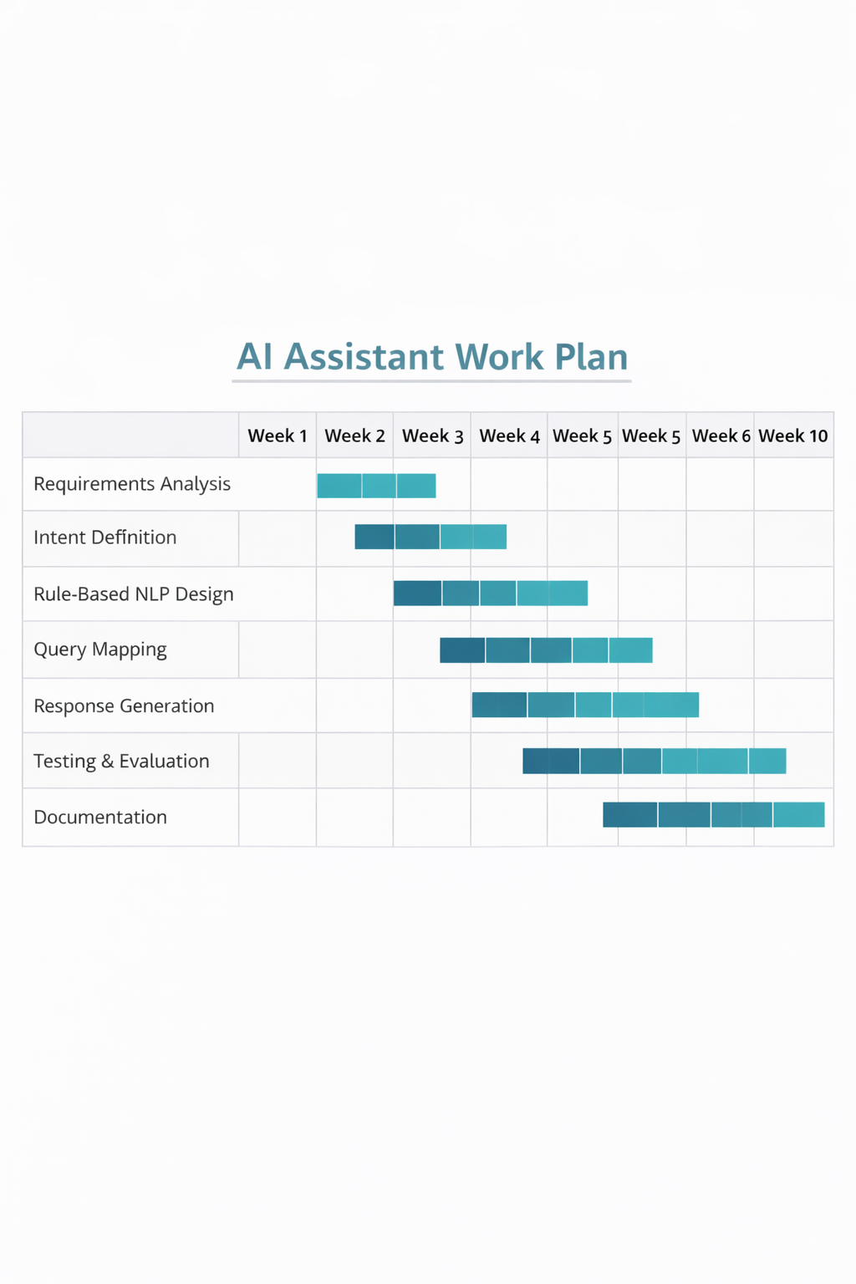

10. Ethical Considerations
The AI assistant does not collect personal customer data. It processes aggregated business data for reporting purposes. Transparency will be maintained by clearly communicating the limitations of the rule-based approach to users.

11. Risks and Limitations
Potential risks include misinterpretation of user queries and limited flexibility in handling complex requests. These limitations are acceptable within the scope of an academic MSc project and are mitigated through predefined query templates.

12. Conclusion
This individual component focuses on the development of an AI-based business insights assistant for eyewear retailers. By enabling natural-language access to business data, the system aims to support data-driven decision-making in SME environments.

References
(Harvard – Cite Them Right)
Jurafsky, D. and Martin, J.H. (2021) Speech and Language Processing. 3rd edn. Hoboken: Pearson.

Chaffey, D. (2019) Digital Business and E-Commerce Management. 7th edn. Harlow: Pearson Education.
Heizer, J., Render, B. and Munson, C. (2020) Operations Management: Sustainability and Supply Chain Management. 13th edn. Harlow: Pearson.
Laudon, K.C. and Traver, C.G. (2021) E-Commerce: Business, Technology, Society. 16th edn. Harlow: Pearson Education.
Turban, E., Pollard, C. and Wood, G. (2018) Information Technology for Management: On-Demand Strategies for Performance, Growth and Sustainability. 11th edn. Hoboken: Wiley.
Chen, H., Chiang, R.H.L. and Storey, V.C. (2012) ‘Business Intelligence and Analytics: From Big Data to Big Impact’, MIS Quarterly, 36(4), pp. 1165–1188.
Rouse, M. (2020) Inventory Management System. Available at: https://www.techtarget.com (Accessed: 15 January 2026).
PostgreSQL Global Development Group (2024) PostgreSQL Documentation. Available at: https://www.postgresql.org/docs/ (Accessed: 15 January 2026).
Flask Documentation (2024) Flask Web Framework. Available at: https://flask.palletsprojects.com (Accessed: 15 January 2026).
React Documentation (2024) React – A JavaScript Library for Building User Interfaces. Available at: https://react.dev (Accessed: 15 January 2026).

